1. Write a program to set your name and age by a static method and get them in an another static method

import java.util.Scanner;

public class PortfolioMethod

{

public static String detailsdisplay(String fname, String age)

{

System.out.println("name: " +fname);

System.out.println("age: " +age);

return fname;

}

public static String detailsEntry()

{

Scanner sc = new Scanner(System.in);

System.out.println("Enter name:");

String fname = sc.nextLine();

System.out.println("Enter age:");

String age = sc.nextLine();

return detailsdisplay(fname,age);

}

public static void main(String[] args)

{

detailsEntry();

}

}

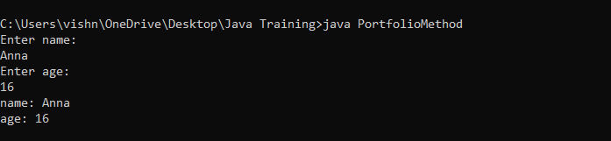

2 . Write a program to find the factorial of a number (**static method**)

* Output – “Factorial of <given number> is <result>.

import java.util.Scanner;

public class FactorialMethod

{

public static void main (String args[])

{

Scanner sc = new Scanner(System.in);

System.out.println("Enter the number you want to find factorial");

int a = sc.nextInt();

int fact = factorialFind(a);

System.out.println("Factorial is: " +factorialFind(a));

}

public static int factorialFind(int a)

{

int fact=1;

for(int i=1;i<=a;i++)

{

fact=fact*i;

}

return fact;

}

}

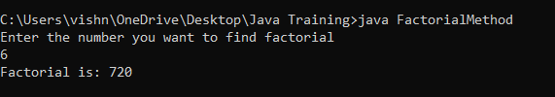

3. Write a program to check whether the given number is Palindrome/Not by using **static methods**.

* Method 1- to find the reverse (pass the number in argument)
* Method 2-to check palindrome/not

import java.util.Scanner;

public class PaliondromeMethod

{ewqqqqqqqqqqqqqqqqqqqqqqqqqqqqqqqqqqqqqqqqqqqqqqqqqqqqqqqqqqqqqqqqqqqqqqqqqqqqqqqqqqqqqqqqqqqqqqqqqqqqqqqqqqqqqqqqqq1`

public static void main (String args[])

{

Scanner sc = new Scanner(System.in);

System.out.println("Enter the number");

int a = sc.nextInt();

int rev=palindromeFind(a);

palindromecheck(rev,a);

}

public static int palindromeFind(int a)

{

int temp=a;

int r;

int rev=0;

while(temp!=0)

{

r=temp%10;

rev=rev*10+r;

temp=temp/10;

}

return rev;

}

public static void palindromecheck(int rev, int a)

{

if(rev==a){

System.out.println("Given number is a paliondrome");

}

else

{System.out.println("Given number is not a paliondrome");}//

}}

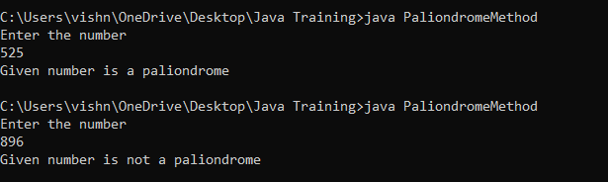

4.Write a program to check whether the candidate is eligible for Voting (Use **static method** and boolean return type).

import java.util.Scanner;

public class Voting

{

public static boolean ageCheck(int a)

{

if(a>18)

{

// System.out.println("Your are eligible to Vote");

return true;

}

else

{

//System.out.println("Your are not eligible to Vote");

return false;

}

}

public static void main (String args[])

{

System.out.println("Enter you Age:");

Scanner sc = new Scanner(System.in);

int a = sc.nextInt();

boolean i = ageCheck(a);

System.out.println("Is Voter: " +i);

}

}

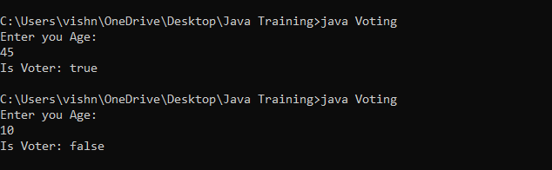

5. Write a program to deposit and withdraw amount from bank account (Withdrawal amount do not exceeds the current balance). Add an extra method to check the account balance. (**static methods**)

import java.util.Scanner;

public class Bank

{

public static void main (String args[])

{

Scanner sc = new Scanner(System.in);

System.out.println("Enter the account number");

Double a = sc.nextDouble();

System.out.println("Enter the current balance");

Double b = sc.nextDouble();

System.out.println("Amount to be deposited");

Double c = sc.nextDouble();

System.out.println("Amount to be withdrawn");

Double d = sc.nextDouble();

Double balance = sc.nextDouble();

if(d>b)

{

System.out.println("Balance not sufficient");

}

balance(b,c,d);

}

public static double balance(double b,double c,double d)

{

double balance=b+c-d;

System.out.println("Deposited and the balance amount is: " +balance);

return balance;

}

}

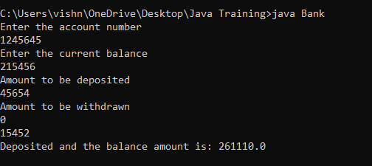

6. Write a program to check whether the customer have discount (get 20% discount if total amount is greater than 5000) or not and get the final amount in main method. (**static methods**)

* Get prices of items using parameterized method
* Method 1 - Calculate total amount
* Method 2 - Check discount

import java.util.Scanner;

public class Shopping

{

public static void main (String args[])

{

Scanner sc = new Scanner(System.in);

System.out.println("Enter the first product price");

float a = sc.nextFloat();

System.out.println("Enter the second product price");

float b = sc.nextFloat();

System.out.println("Enter the third product price");

float c = sc.nextFloat();

float sum=0;

sum=total(a,b,c);

check(sum);

}

public static float total(float a,float b,float c)

{

float sum;

sum=a+b+c;

System.out.println("Total price is : "+sum);

return sum;

}

public static void check(float sum)

{

if (sum>5000)

{

float discount= (20*sum)/100;

float afterdiscount = sum - discount;

System.out.println("Total price after discount is : "+afterdiscount);

}

else

{

System.out.println("Have a nice day");

}

}

}

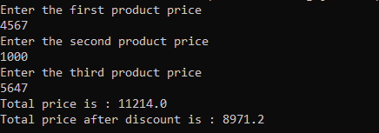

**Second Try**

import java.util.Scanner;

public class Shopping

{

public static void main (String args[])

{

System.out.println("Enter 3 product prices");

Scanner sc=new Scanner(System.in);

int a[]=new int[3];

int sum=0;

sum=total(a);

check();

}

public static int total(int a)

{

int sum;

for(int i=0;i<10;i++)

{

a[i]=sc.nextInt();

}

for(int i : a)

{

sum=sum+i;

}

System.out.println("Total price is : "+sum);

return sum;

}

public static void check(int sum)

{

if (sum>5000)

{

int Discount=(20/100)*sum;

System.out.println("Total price after discount is : "+Discount);

}

else

{

System.out.println("Total price is : "+sum);

}

}

}

7. Write a program to find the

a) Average of three integer numbers, three float numbers (should have same method name)

b) Area of figures (circle, rectangle, square) by using three methods(should have same method name)

**a]**

import java.util.Scanner;

public class AveragePoly {

public static void main(String[] args)

{

Scanner sc = new Scanner(System.in);

System.out.println("Integer Addition");

System.out.print("Enter the first number: ");

int a = sc.nextInt();

System.out.print("Enter the second number: ");

int b = sc.nextInt();

System.out.print("Enter the third number: ");

int c = sc.nextInt();

System.out.println("The average of entered integer numbers are:" + avr(a, b, c) );

System.out.println("Float Addition");

System.out.println("Enter the first number: ");

float d = sc.nextInt();

System.out.println("Enter the second number: ");

float e = sc.nextInt();

System.out.println("Enter the third number: ");

float f = sc.nextInt();

System.out.println("The average of entered float numbers are:" + avr(d, e, f) );

}

public static int avr(int a, int b, int c)

{

return (a + b + c) / 3;

}

public static float avr(float d, float e, float f)

{

return (d + e + f) / 3;

}

}

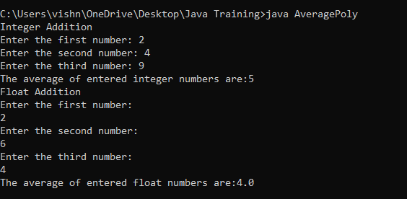

**b]**

import java.util.Scanner;

public class AreaPoly {

public static void main(String[] args)

{

Scanner sc = new Scanner(System.in);

System.out.println("Area of circle");

System.out.println("Enter the radius of the circle: ");

double a = sc.nextInt();

System.out.println("The area of circle is:" + area(a) );

System.out.println("Area of rectangle");

System.out.println("Enter the length");

int b = sc.nextInt();

System.out.println("Enter the breadth");

int c = sc.nextInt();

System.out.println("The area of rectangle is:" + area(b,c) );

System.out.println("Area of square");

System.out.println("Enter the one side length");

int d= sc.nextInt();

System.out.println("The area of square is:" + area(d) );

}

public static double area(double a)

{

return (3.14*a*a);

}

public static int area(int b, int c)

{

return (b*c);

}

public static int area(int d)

{

return (d*d);

}

}

